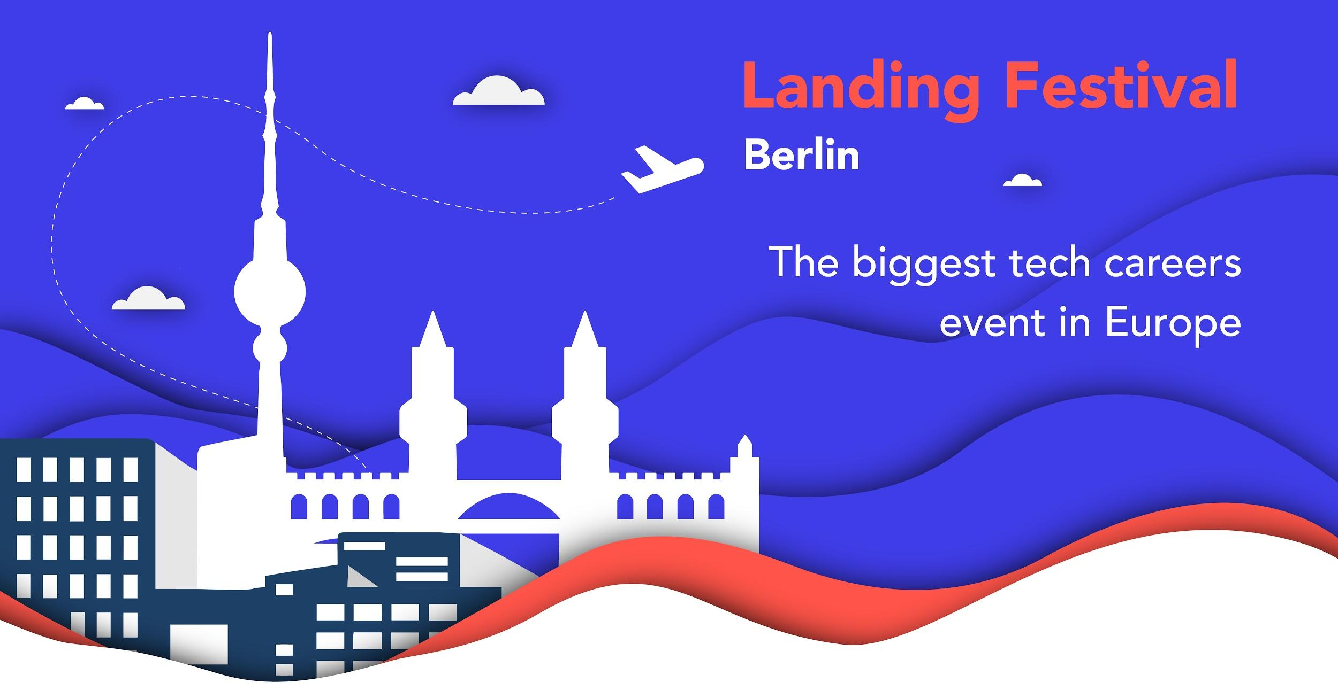
Description:

Europe’s biggest tech careers event. Two days of intensive learning and networking featuring talks, panels, expert sessions, workshops, a job fair, entertainment activities and a massive boat party to wrap up all the craziness.

Whether you are looking for your next job, want to discover 2018’s hottest tech trends, or share knowledge and passion with like-minded individuals, Landing Festival is the place to be.

Website: https://landingfestival.com/berlin
Register: https://landingfestival.com/berlin/tickets

Dates:
14th and 15th March 2018, Berlin
From 16h00 until 21h30

Location:
Telekom Hauptstadtrepräsentanz
Berlin, Germany

