

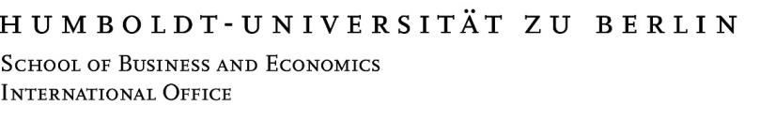

**FACT SHEET 2025/26**



|  |  |  |  |
| --- | --- | --- | --- |
| **Contact:** | Inbound exchange: [incomings-wiwi@hu-berlin.de](mailto:incomings-wiwi@hu-berlin.de)  Outbound exchange: outgoings-wiwi@hu-berlin.de | | |
| **International Office** | Head of International  Office  Irene Orrigo  Phone: +49 30 2093 99504 [international@wiwi.hu-berlin.de](mailto:international@wiwi.hu-berlin.de) | Head of Study and International Affairs Dr. Anja Schwerk Phone: +49 30 2093 99518 schwerk@wiwi.hu-berlin.de  (please contact for contractual matters/partner  agreements) | Deputy Dean for Study and International Affairs  Prof. Dr. Ralf Maiterth  Phone:  +49 30 2093 99021  ralf.maiterth@wiwi.hu-berlin.de |
| Student Assistant  tba  [incomings-wiwi@hu-berlin.de](mailto:international@hu-berlin.de) |
| **Address** | Visiting: Spandauer Str. 1, Room 3, 10178 Berlin, Germany  Postal: Unter den Linden 6, 10119 Berlin, Germany | | |
| **Website** | University: www.hu-berlin.de School: www.wiwi.hu-berlin.de/en  International Office: https://www.wiwi.hu-berlin.de/en/international-office-1 | | |
| **Erasmus Code** | D BERLIN 13 | | |
|  | **Winter term 2025/2026** | **Summer term 2026** | |
| **Lecture Period (incl. Welcome Weeks)** | 13.10.2025– 14.02.2026 | 13.04.2026-19.07.2026 | |
| **Academic Holiday** | 22.12.2025 – 04.01.2026 | tba | |
| **Examination Period** | Feb-March | July-August | |
| **Int. Language Course** | September 2025 | March 2026 | |
| **Nomination Deadline** | 15.05.2025 | 15.11.2025 | |
| **Nomination platform:** | <https://huberlin.moveon4.de/form/63ce7e9a14213d325a21f1ca/eng> | | |
| **Application Deadline** | 15.04.2025 - 31.05.2025 | 15.10.2025 - 30.11.2025 | |
| **Application Deadline Student Dorms** | 31.05.2025 | 30.11.2025 | |
| More tips see: <https://www.international.hu-berlin.de/en/coming-to-humboldt-universitat/services-informations/accommodation> | | |
| **Course List and Course Choice** | The primary emphasis of the courses is on imparting rigorous and quantitative methods of economic analysis. Mathematical skills are highly recommended for taking courses at HU’s School of Business and Economics.  https://www.wiwi.hu-berlin.de/en/international-office-1/incoming-exchange-students/course-selection | | |
| **Language Requirements** | Bachelor students: German language proficiency B2 OR English C1  Master students: English language proficiency C1 | | |